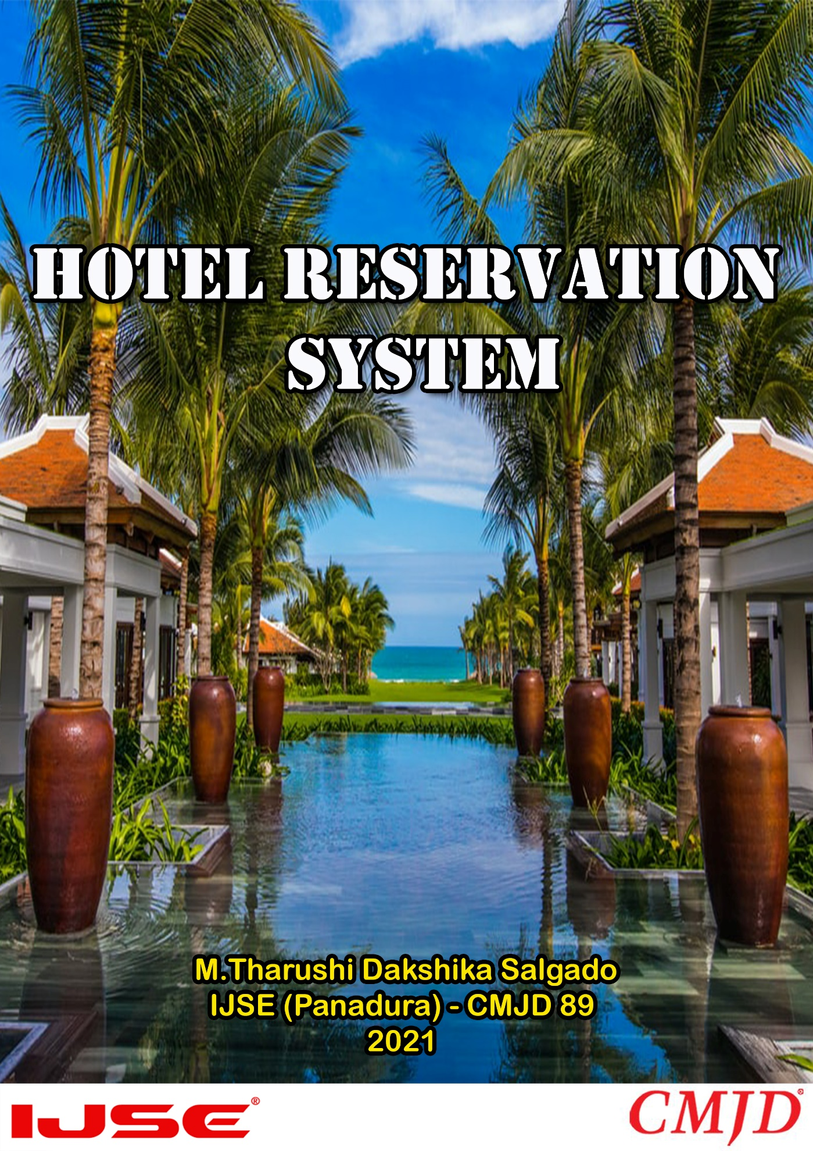

**Acknowledgement**

We wish to thank my parents for their personal support or attention who inspire me to go my own way. At last, but not the least we want to thank my friends who treasured me for my hard work and encouraged.

We would like to express my deepest appreciation to all those who provided me the possibility to complete this report. Furthermore, we would also like to acknowledge with much appreciation the crucial role of the staff or Mr. Hasika & Mr. Niroth, who gave the permission to use all required equipment and the necessary materials to complete the task.

**Content**

Acknowledgement 1

Content 2

Introduction 3

Motivation 4

Objective 4

Scope 5

Interfaces (Frontend)

Designs 6

Source Codes 16

Backend 19

Diagrams

* Entity Relationship Diagram 21
* Use-case Diagram 22
* Class Diagram 23

Project Timeline 24

Conclusion 25

**Introduction**

This website was designed for M & T Villa using Angular, Nodejs, and MySQL. This website helps the user reserve the hotel room of his/her choice online.

The end user may view hotels and hotel rooms based on various categories using this website. It also allows users to register on the website in order to keep track of their own personal information. By signing in, he or she may view and manage his or her profile. New users are given the option to sign up.

The customer's personal information is stored in the user account. In the profile module, he/she may also see the reservation he/she has made. The customer has the option to cancel their reservation before the motel's cancellation date. Also, if a customer wants to update her or his reserve, they can do it.

The website's configurations may be controlled and managed by the system administrator. She or he has the ability to add and modify the offerings.

M & T Villa aims to provide leisure travelers with an expedient, informative, and user-friendly website where they can book reservations for their vacations while receiving excellent customer service.



**(This is only imagination Villa Hotel)**

**Motivation**

The final project is an important and key element of the Comprehensive Master Java Developer (CMJD) program of the Institute of Java & Software Engineering (IJSE), which allows us to enhance our skills and also to practically apply the knowledge.

The M & T Villa hotel was interested in introducing this web platform to run their daily tasks. Because they can provide a more efficient service to their guests. Their main requirements were the guest registration module, room reservation module, customer feedback module, etc.

**Object**

The hotel reservation system, as well as all decision-making, performance, and application processes, are all done by hand. Instead of manual operations, I propose using a system with a smart database to manage all of the current processes with less effort. The project's main goal is to provide a web-based solution for booking hotel rooms online and managing reservations in a way that promotes social distance and less physical touch, as mandated by COVID-19 guidelines in all villas and hotels.

**Scope**

**Scope (01): - Login**

According to the user type provide a login module with a different privileges and functionalities. provide login into the system securely by validating username and password. Also, user can be log out from the system.

**Scope (02): - Registration**

When reserving a room system get details from online register form and system will record customer details as necessarily.

**Scope (03): - Room Reservation**

This module allows customer to select and a decide best possible allocation room.

Customer can book their rooms via web engine (as online guest). The system will automatically check availability of selected room. If the rooms are available customer will be registered by the system.

**Scope (04): - Chat Service**

Customer can send to hotel management their ideas & questions via messages.

**Interface Designs**

* **Login & SignUp**

If a user already has an account with a hotel reservation system, they have to login to this system. When a user clicks on the login button after entering the customer's username and password, they can move to M & T Villa Hotel's home page. If you don't have an account with the hotel reservation system, you have to register by filling in your first name, last name, username, and password. Now users have to login after filling in their username and password, then they can move to the home page.

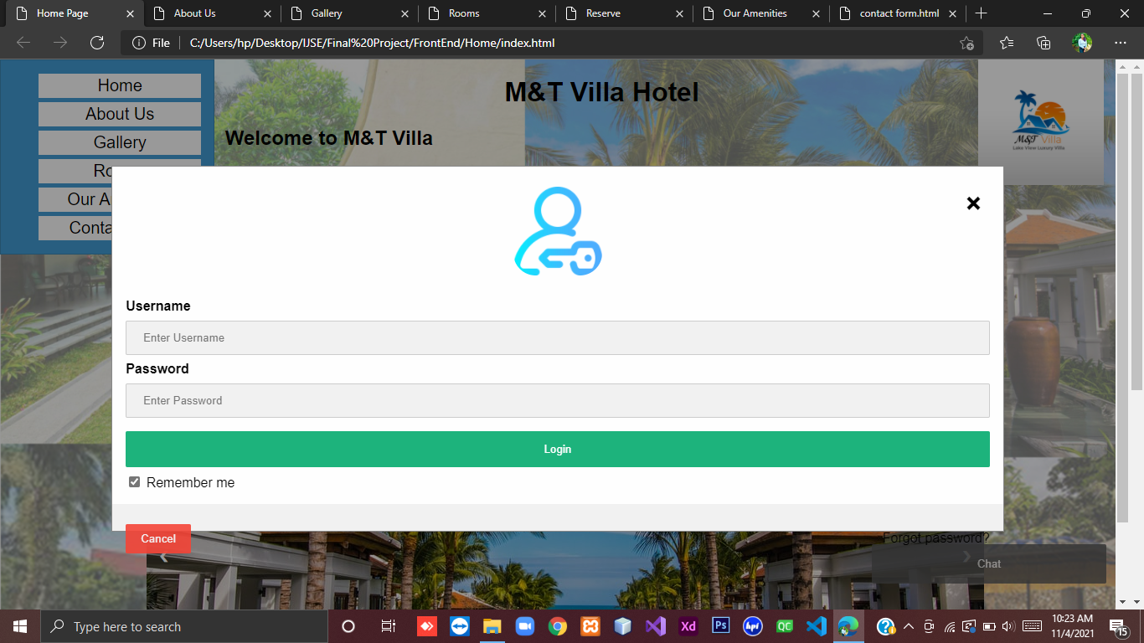

In this step, I created a simple login form that allows users to login using their username and password.

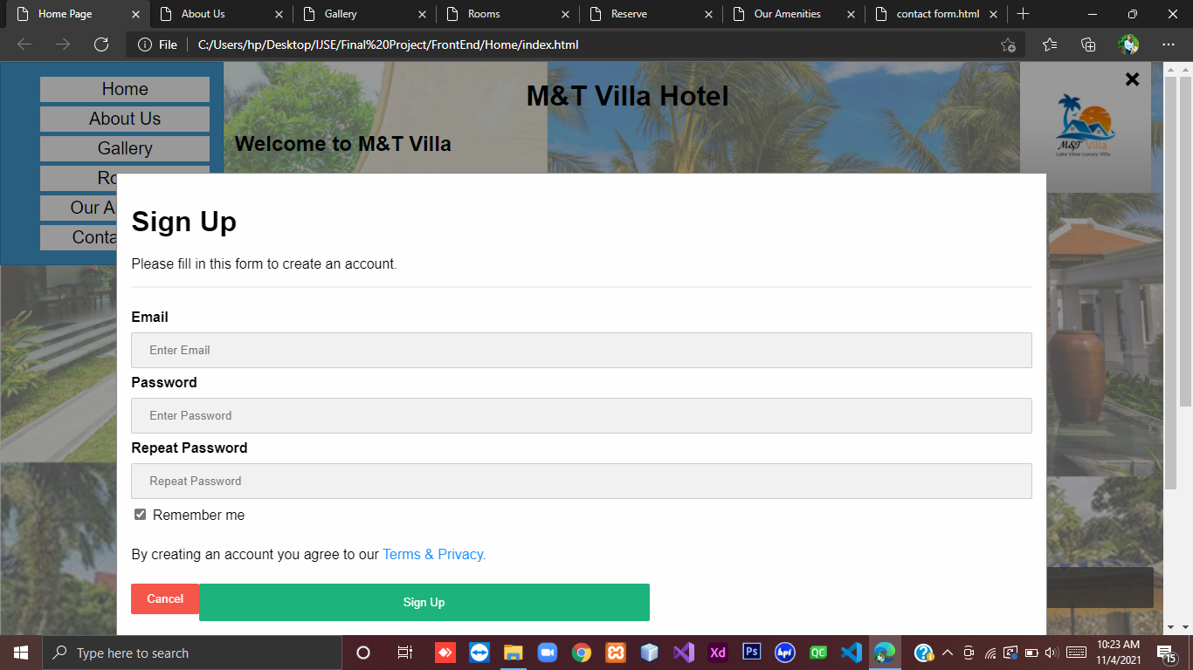

In this step, I created a registration form that allows users to create a new account by filling out a web form. The User Registration form will have First Name, Last Name, Username, and Password, along with Sign Up and Cancel buttons.

If customer click on login or Sign-up button before this these text areas, customer can see an error message “Please fill out this field”.

* **Home**

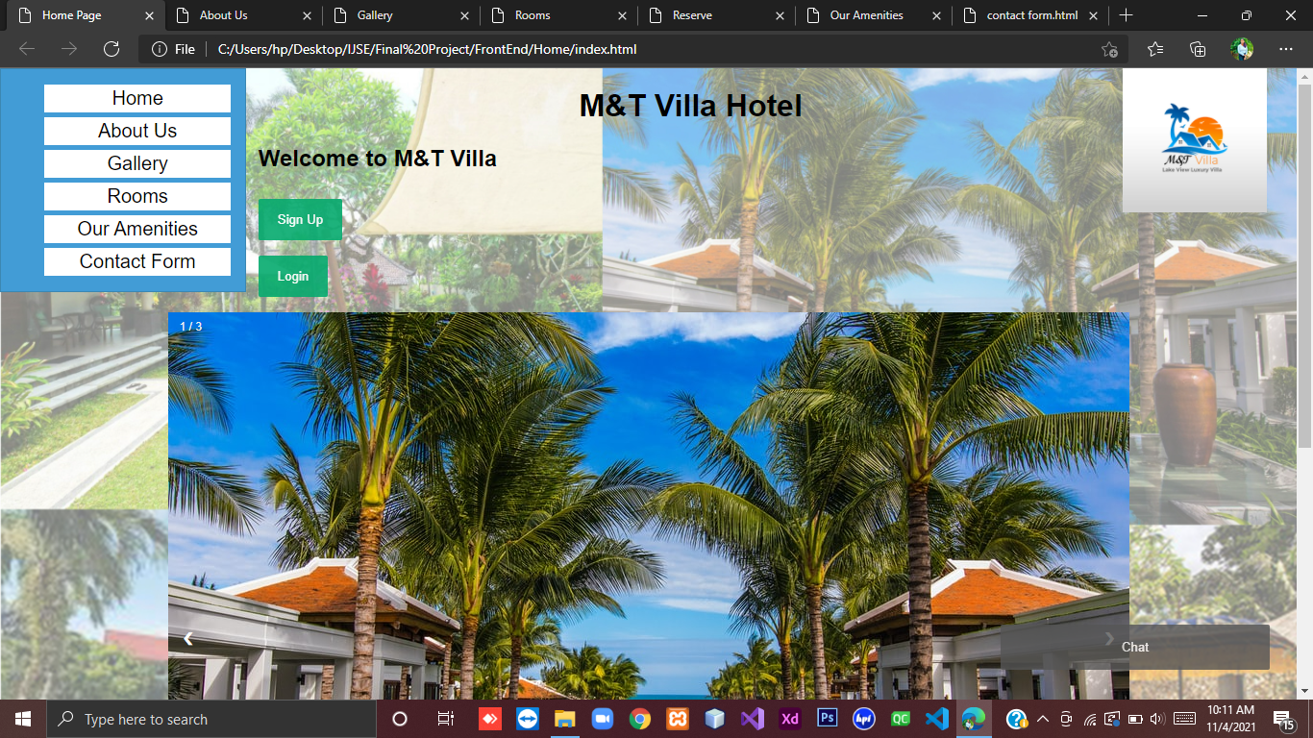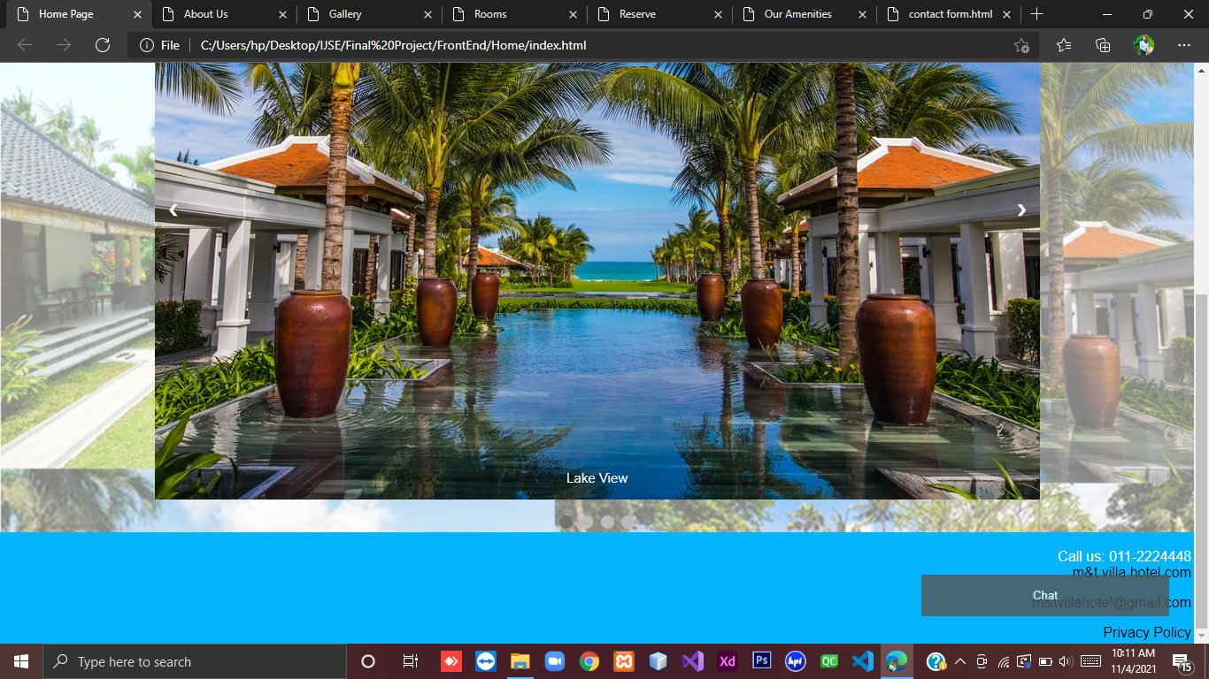

* **About us**

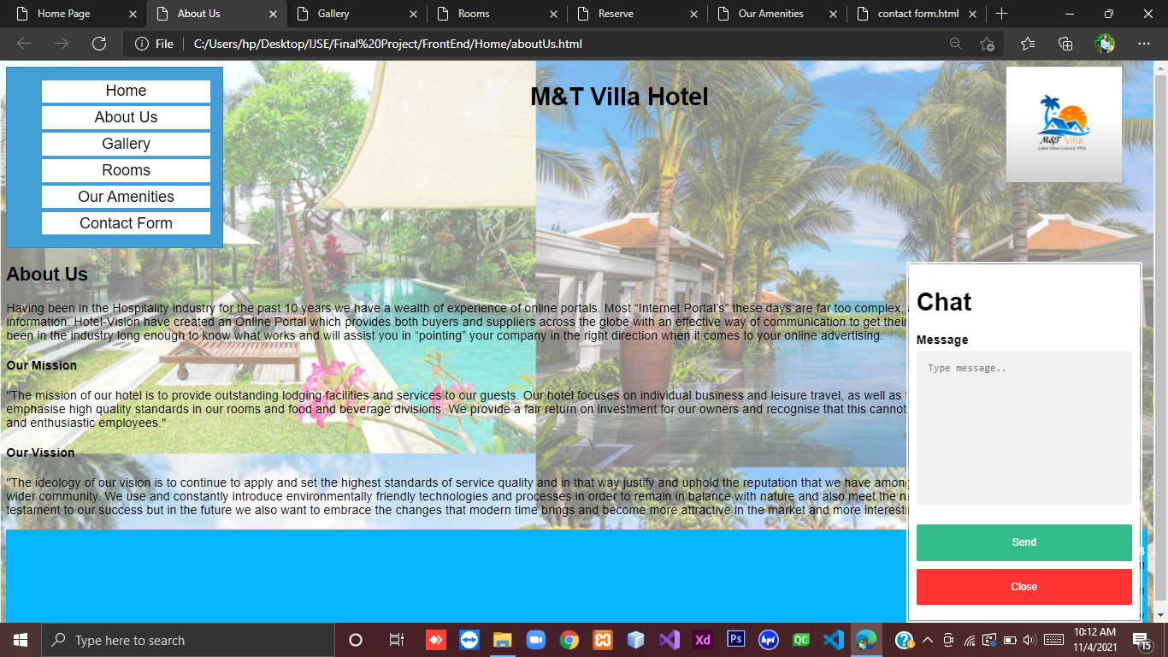

* **Gallery**

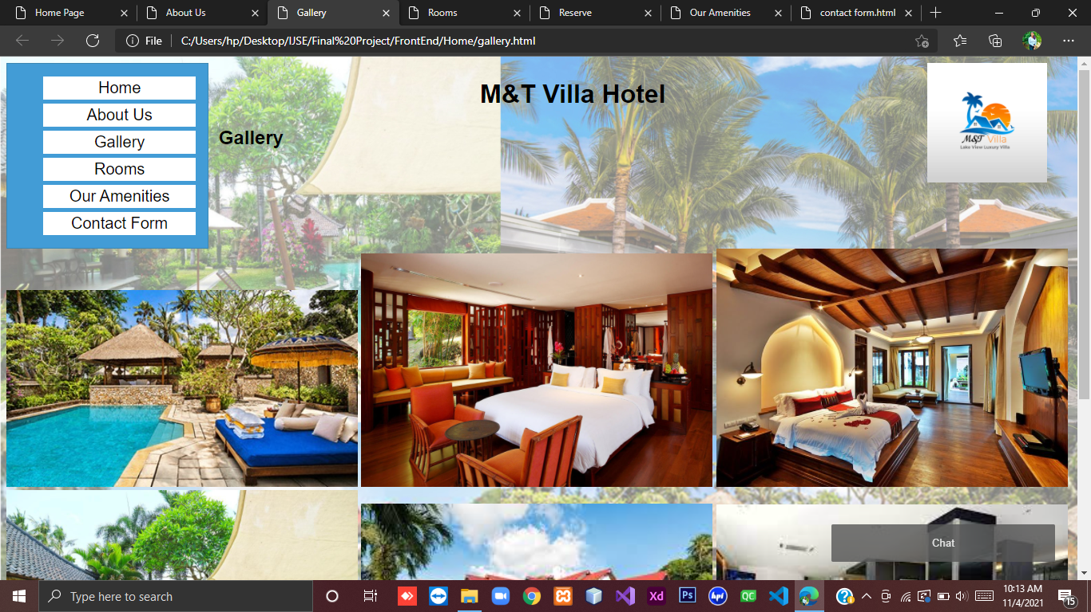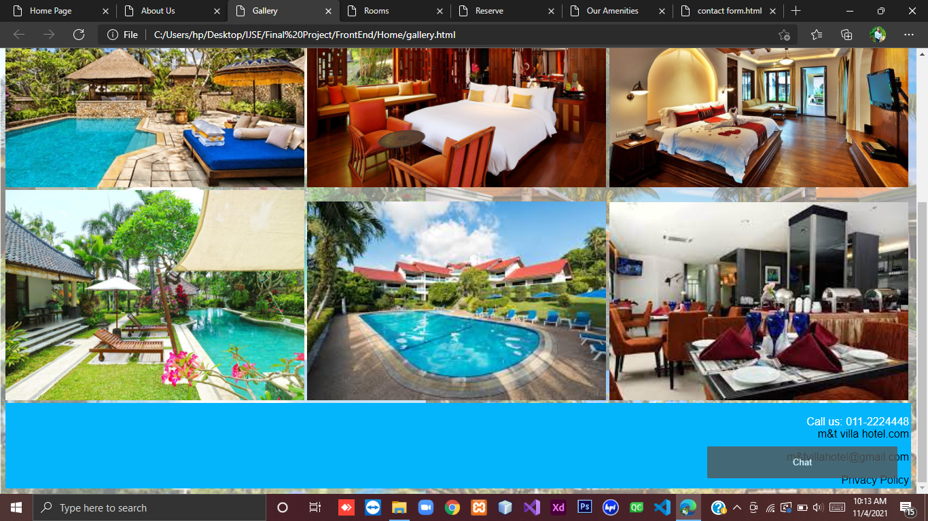

* **Room**

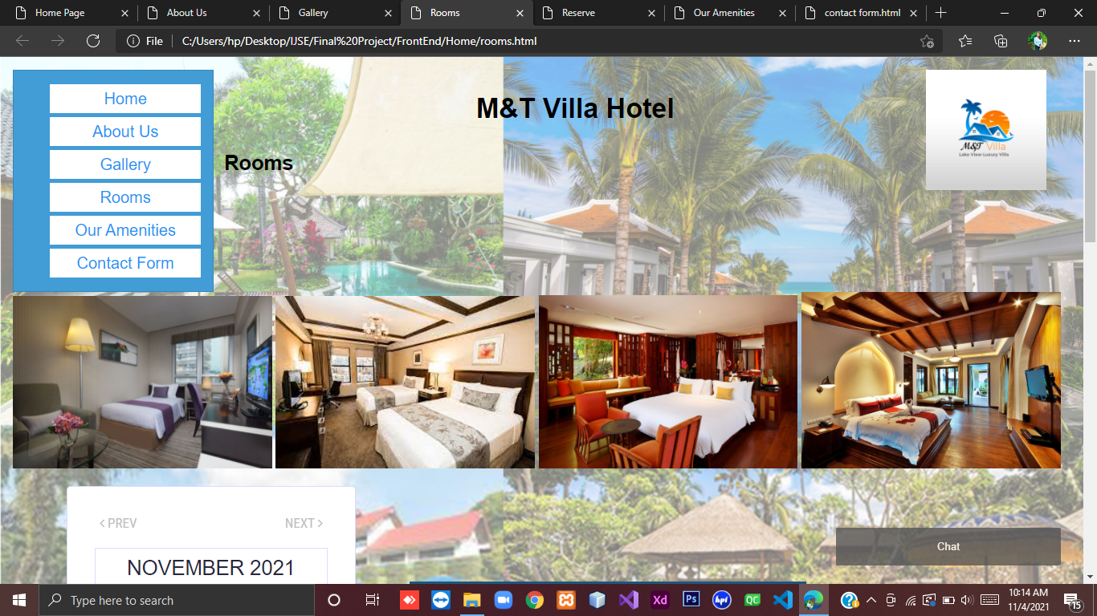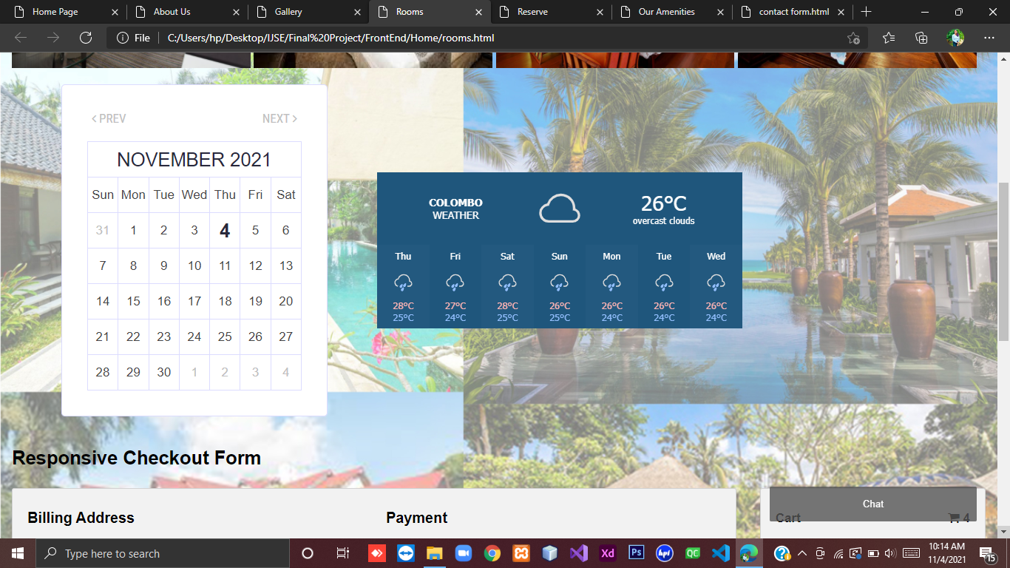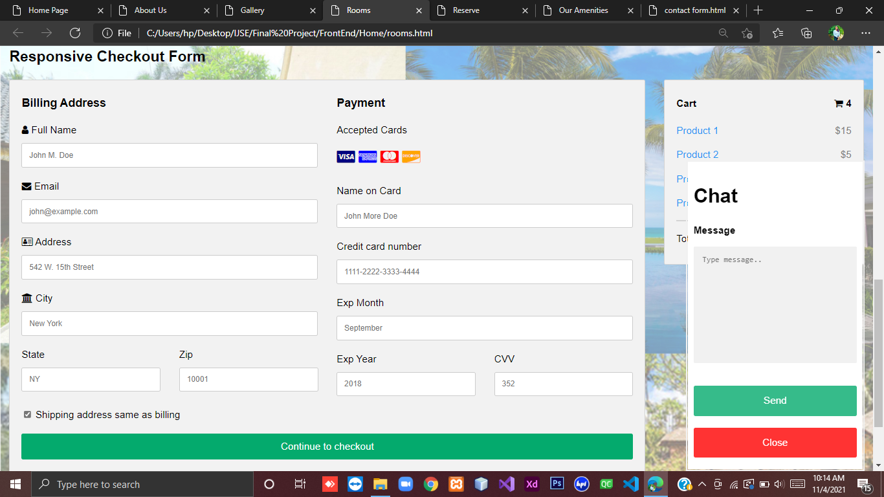

* **Room Reservation**

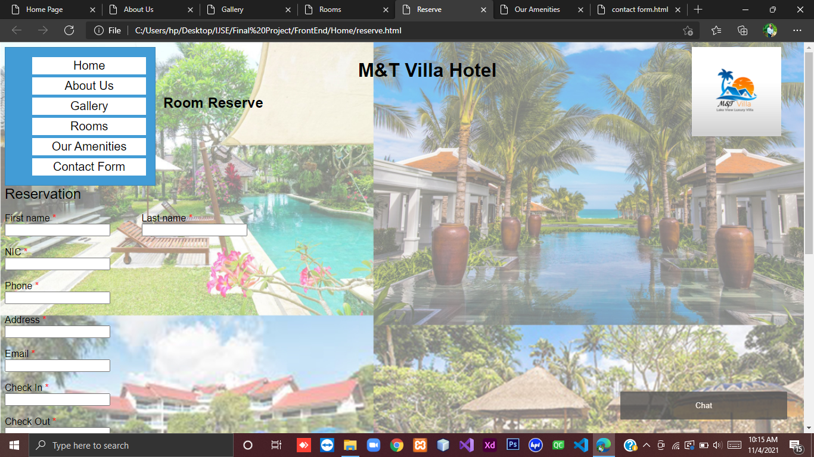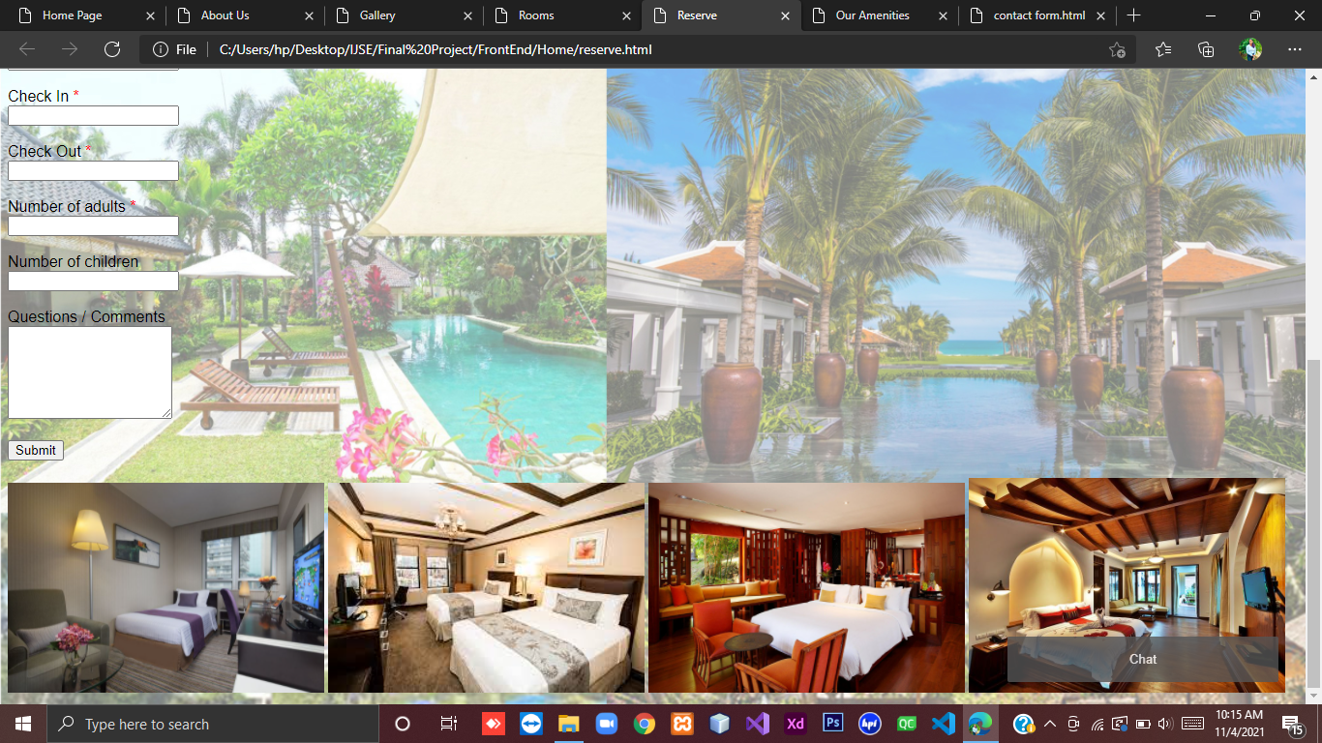

* **Our Amenities**

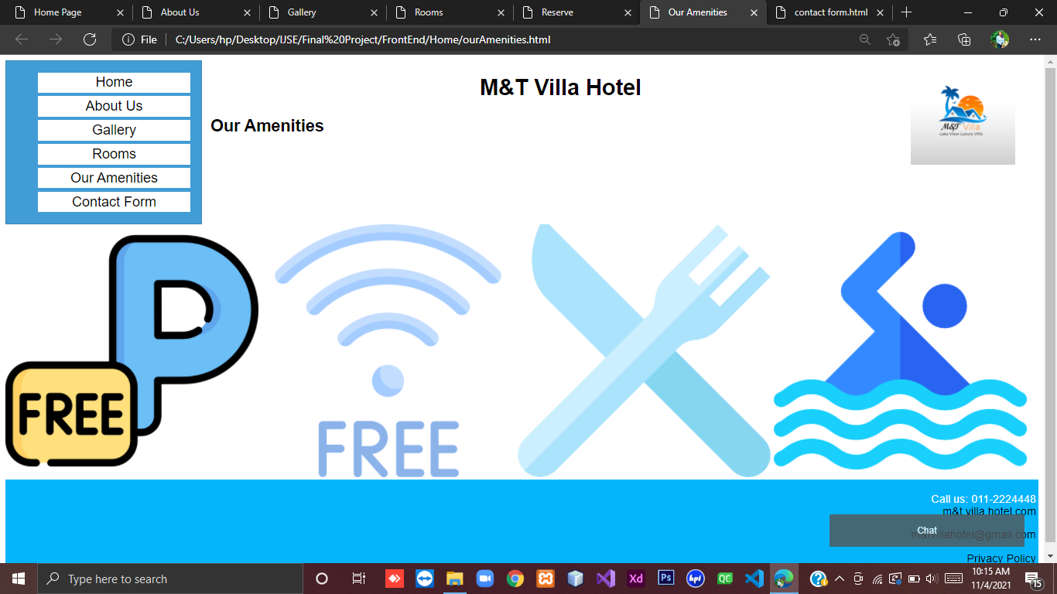

* **Contact Form**

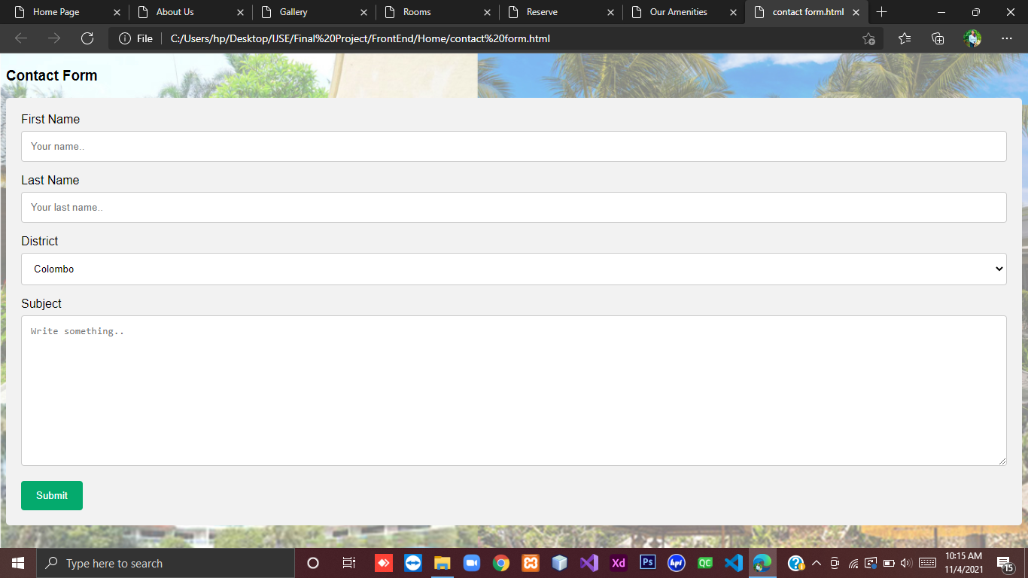

**Source Codes**

* **Home**

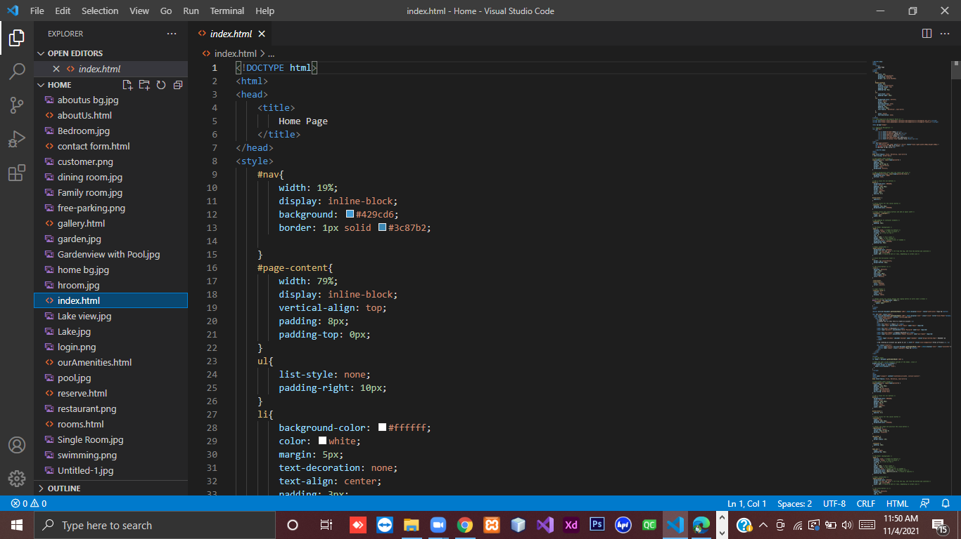

* **About Us**

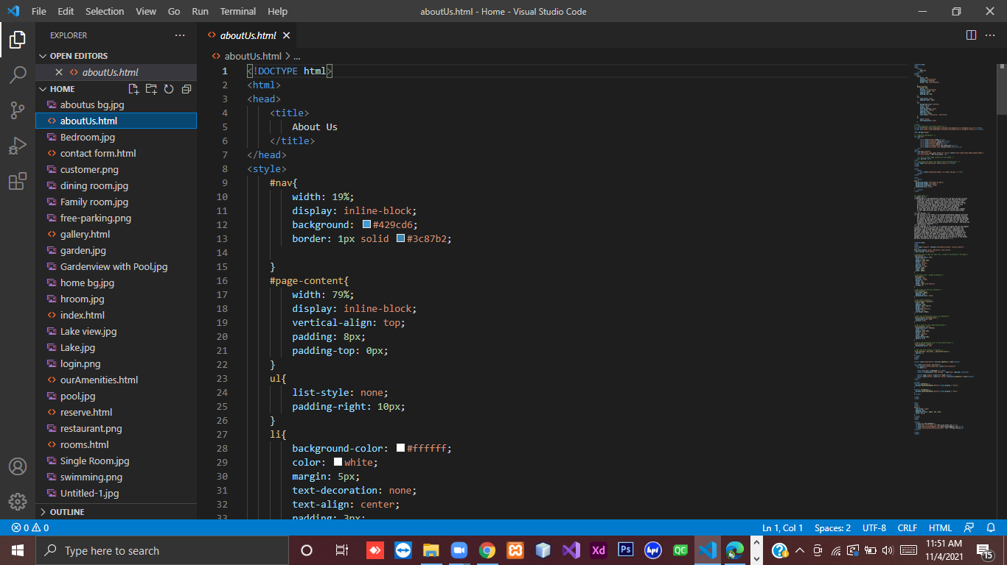

* **Gallery**

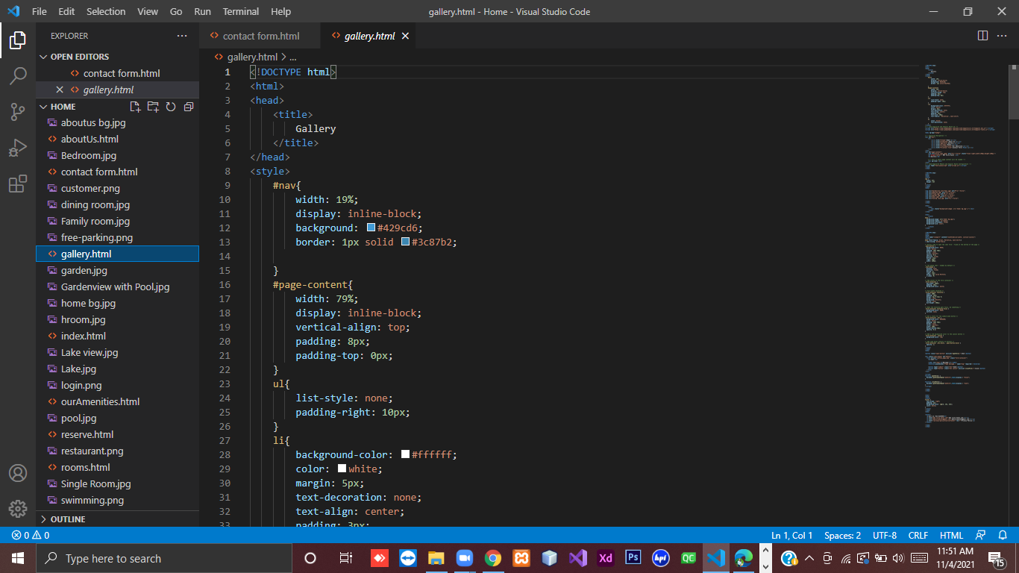

* **Room**

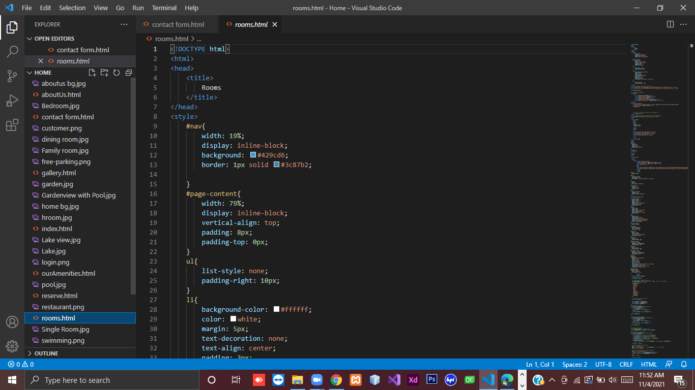

* **Reserve**

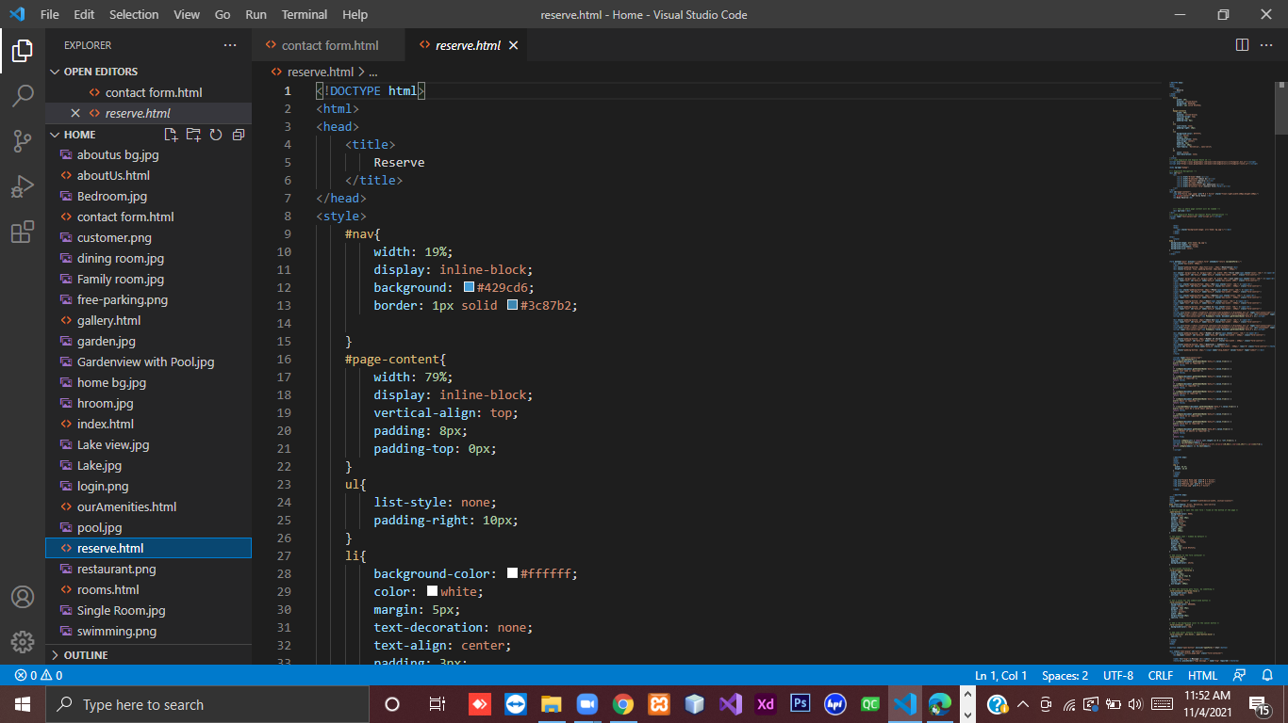

* **Our Amenities**

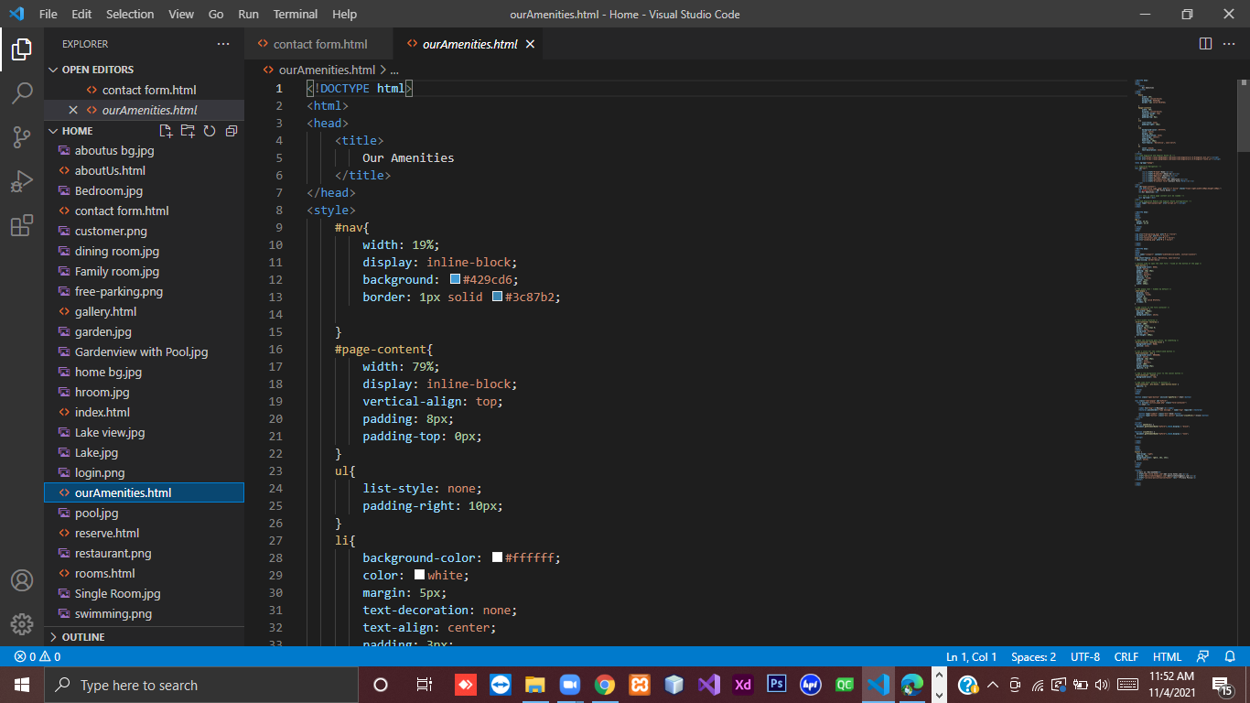

* **Contact Form**

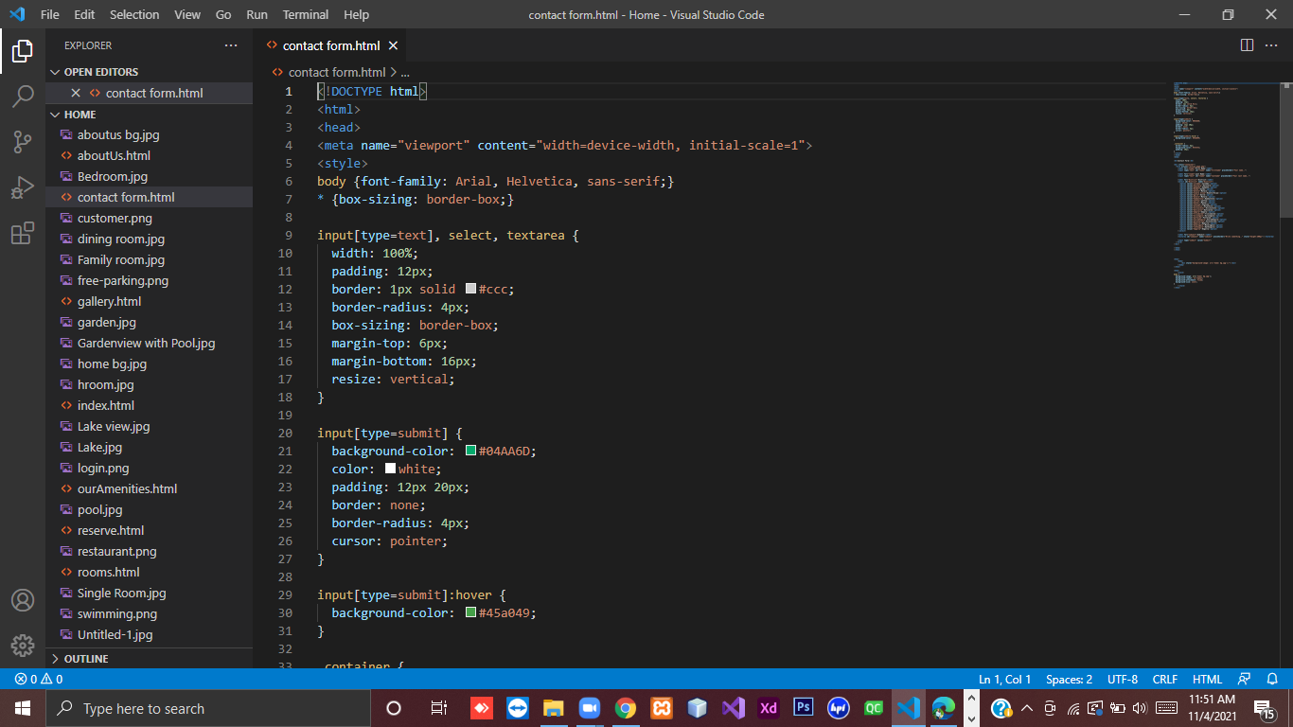

**Backend Source Codes**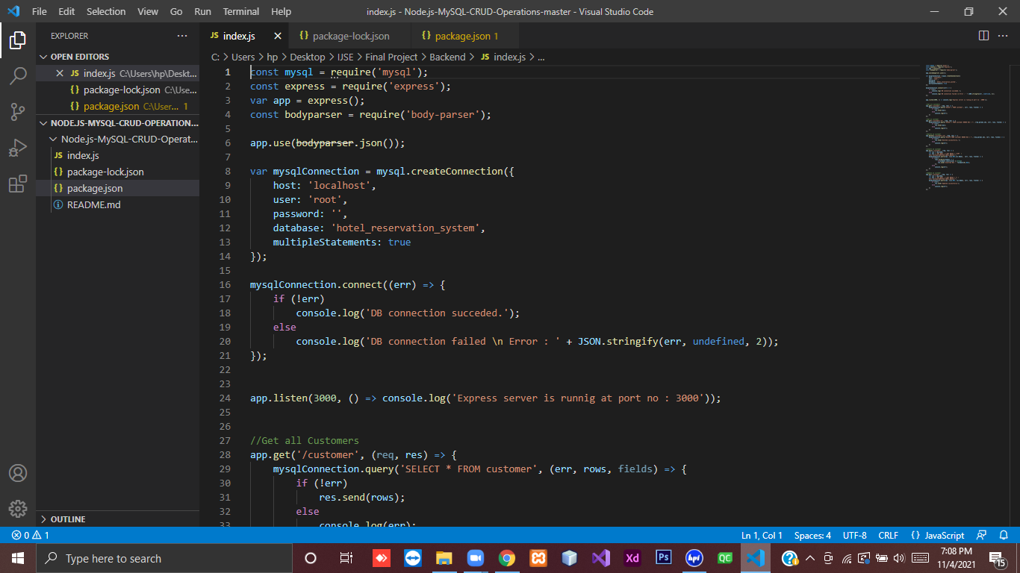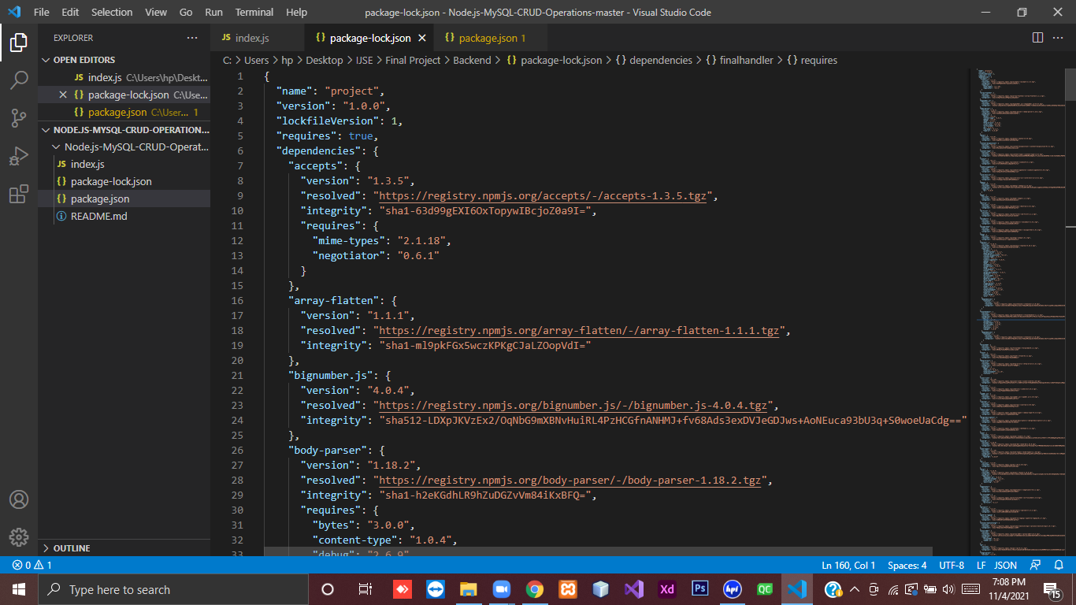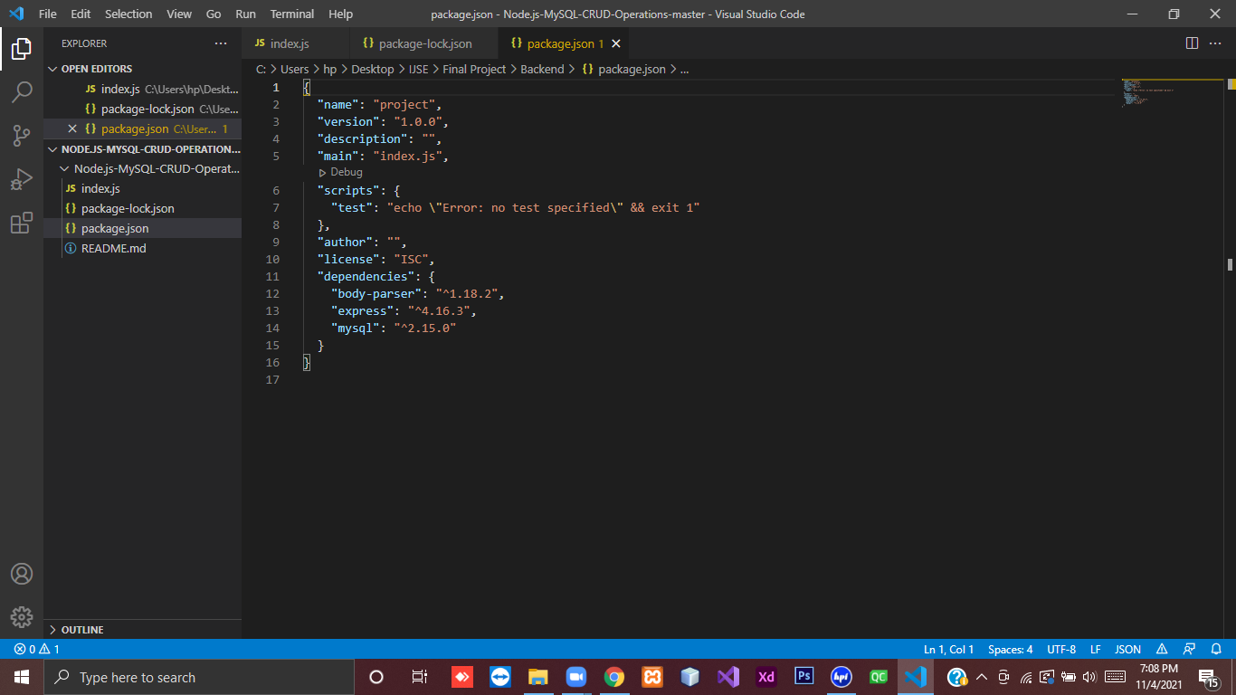

**Diagrams**

* **Entity Relationship Diagram (ER)**

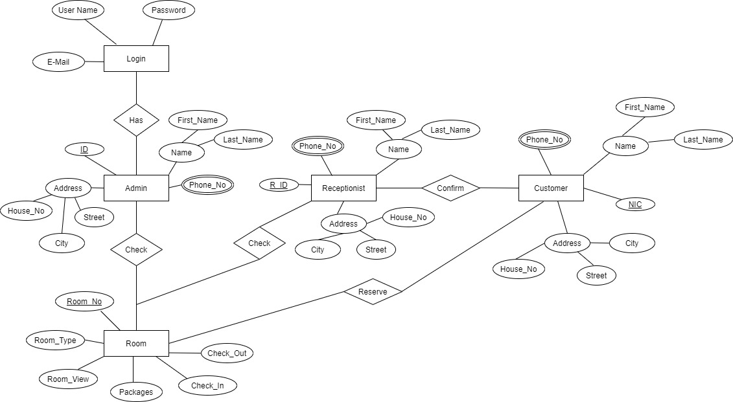

* **Use-case Diagram**

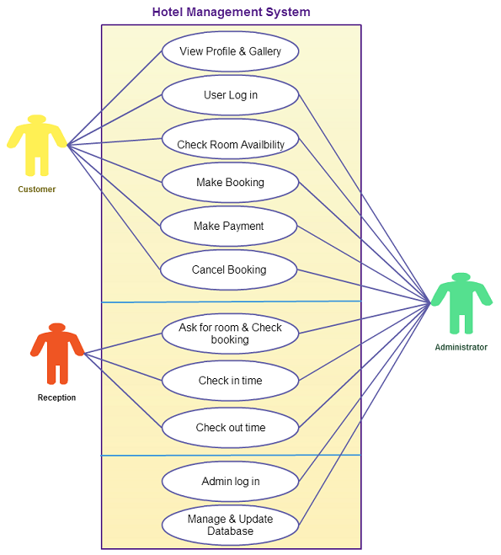

* **Class diagram**

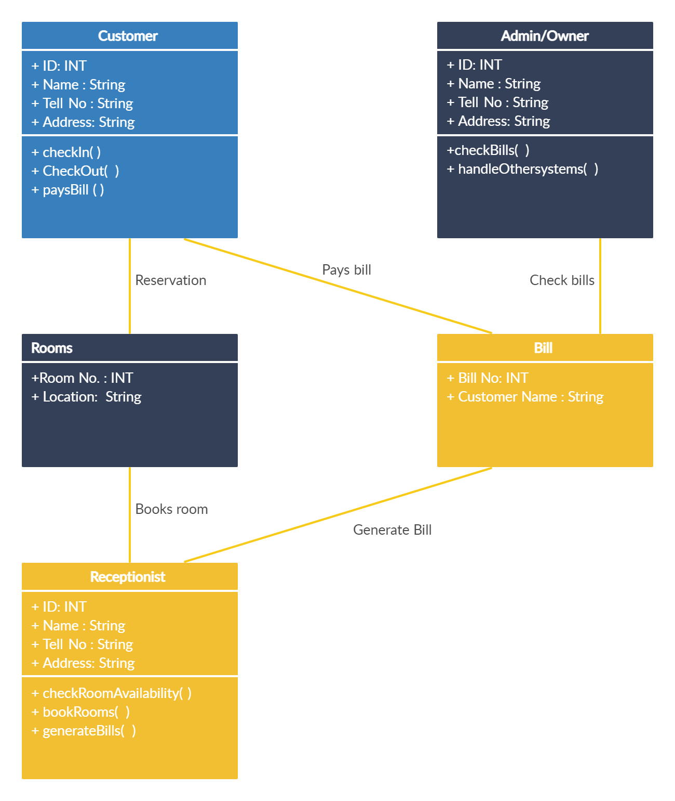

**Project Timeline**

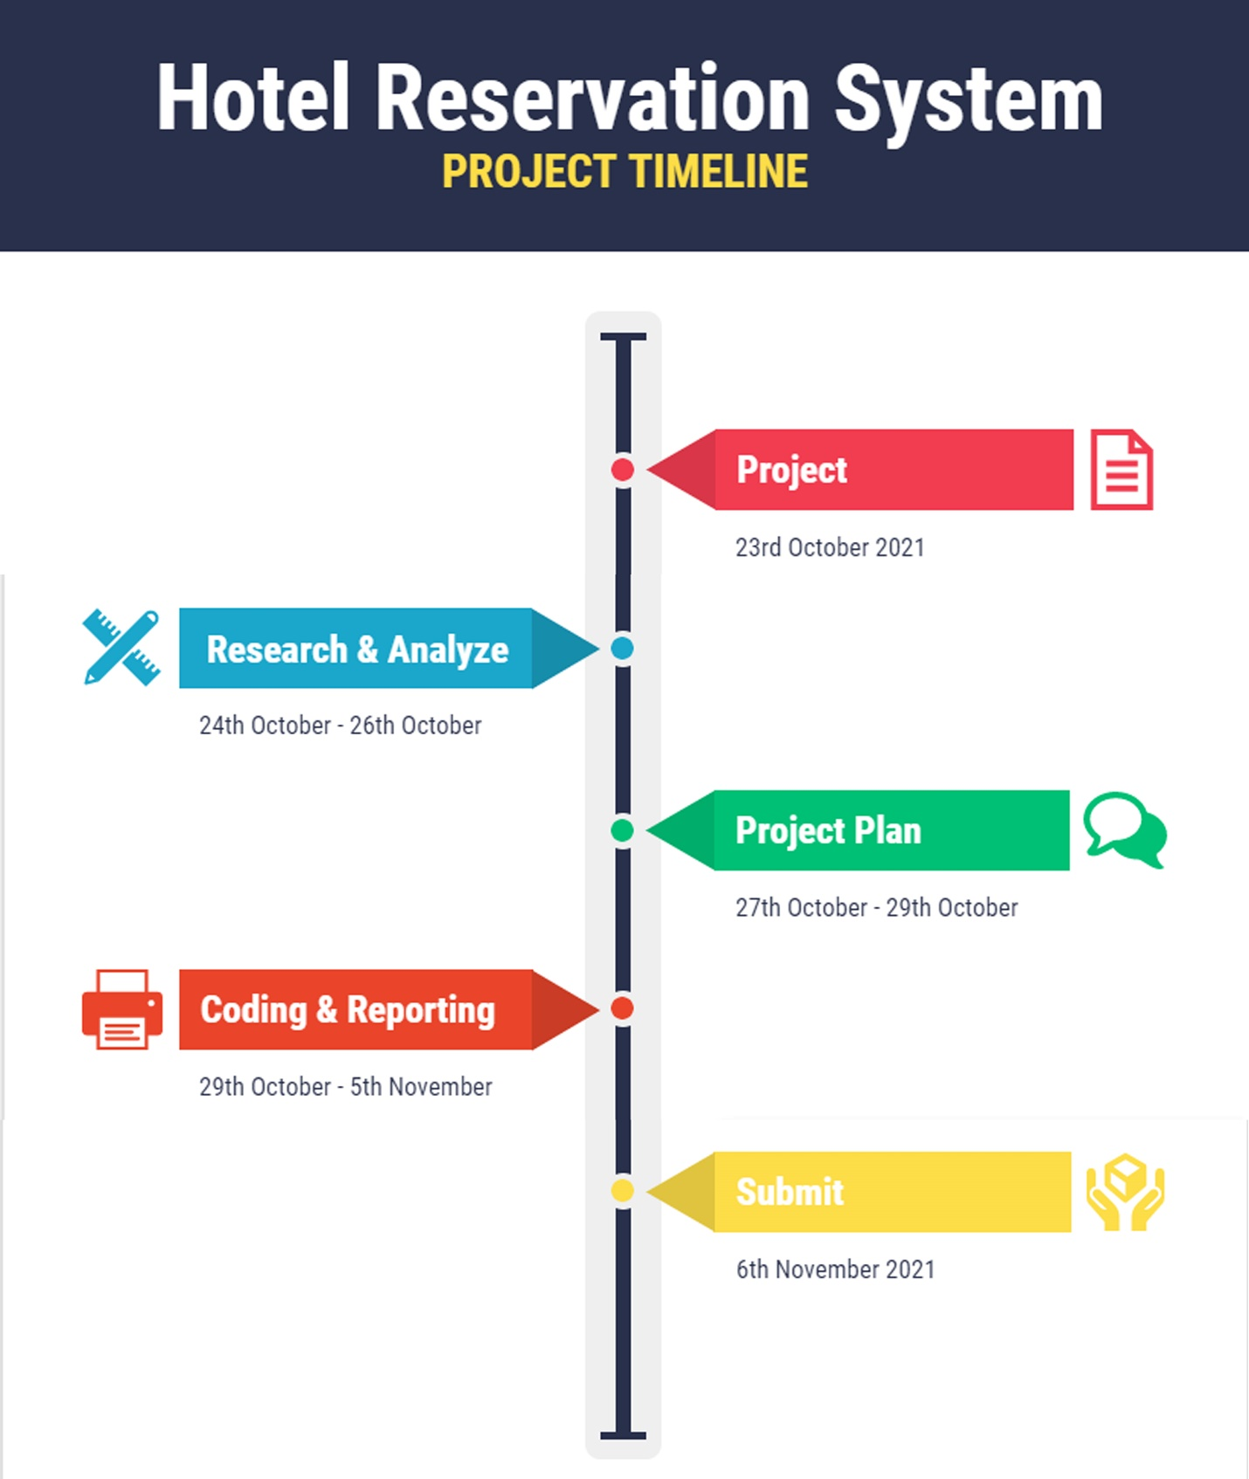

**Conclusion**

The project online hotel reservation system is web-based application that allows the Hotel Manager/Admin and receptionist to handle all hotel activities online easily and safely using interactive GUI anyone can easily learn to use the complete system.

Using this system in the hotel manager and receptionist don’t have to sit and manage the entire activities on paper. M & T Villa hotel manager also works as owner of the hotel, and he will feel comfortable to keep a check on hotel easily from anywhere around the world. This system will give them power and flexibility to manage the entire system from a single online portal. Online guest can make their reservations via hotel website. The website will be so simple and attractive which will make the customer comfortable to use and choose their ideal room. The system allows the manager to check the progress of the hotel from interactive graphs and he will be notified of each new change made in the system. The system allows the manager to keep track on available rooms in the system. Customer can view and book available rooms.

Developed system helps to reduce the time process and its supports to carry out activities

effectively and efficiency.